Animal Activities & Your Health
Student Health Services and Environmental Health & Safety are resources for students involved in animal-related activities associated with their classes.
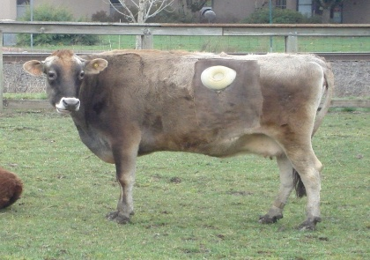
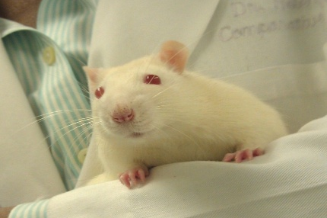
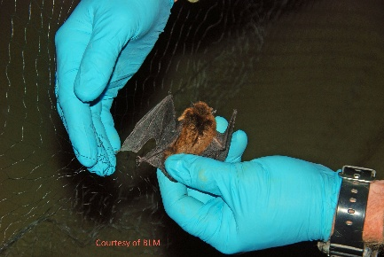

Occupational Health & Safety – Potential areas of concern when working with animals
- Allergen Exposure
- Disease Exposure (zoonoses)
- Animal Handling
- Field Conditions
- Facility Conditions
- Equipment Use
- Animal Procedures

Top Prevention Tips

Minimize allergen exposure:
- Protect your skin, lungs, and clothes from allergens:
  - Use appropriate personal protective equipment (PPE) such as gloves, masks, and goggles when working with animals.
  - Remove them when finished.
  - Wash hands thoroughly after handling animals.
  - Repeat as necessary.
  - Avoid touching your face during work.
  - Do not eat or drink near animals.
- Proper ventilation and hygiene in animal facilities are crucial.

Personal Health History – Risk Factors
Animal work can increase your risk for developing significant health issues, including allergies and diseases from animals (zoonoses).
You may be at increased risk if your medical history includes:
- Allergic conditions including asthma, skin conditions, and previous allergies to animals
- Medications or conditions that compromise or impair the immune system
- Any chronic health condition
- Pregnancy
Consider seeking medical advice specific to you.

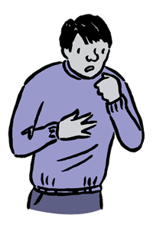
Allergies to Animals - Catch it early!
You can develop allergies as your exposure increases.
- Allergic reactions are often caused by animal proteins in saliva, dander, and urine.
- You may be exposed by direct contact and by inhaling allergens found in the air.
Early symptoms: Stuffy nose, runny nose, sneezing, red or irritated eyes, hives
Late symptoms: Can progress into chronic, severe, even life-threatening conditions such as asthma.

Questions about your health?

Call Student Health Services for assistance: (541) 737-9355
Visit us at https://studenthealth.oregonstate.edu/ for more information!

Department of Environmental Health & Safety (EHS)
Check out our website: https://ehs.oregonstate.edu/
Learn more about:
- Zoonoses
- Biohazards
- Animal Allergies
- Chemical Hazards
- Sharps Injuries
- Physical Injuries
- Methods to reduce risk of disease & injury

Additional Resources
Human Rabies Prevention Program & Guidance Document
Animal Exposure Program Guidance

